**Experiment No. 11**

* 1. **Experiment Name**

Simulation on three-phase (abc) to two-phase (αβ0) transformation system

* 1. **Objectives**
* To develop and perform transformation from three-phase (abc) signal to αβ0 stationary reference frame or the inverse
* To get acquainted with Clark transformation procedure
* To get familiarize with the Simulink platform and Simulink library
  1. **Apparatus**
* Simulink
  1. **Simulink Block Diagram & Waveform**

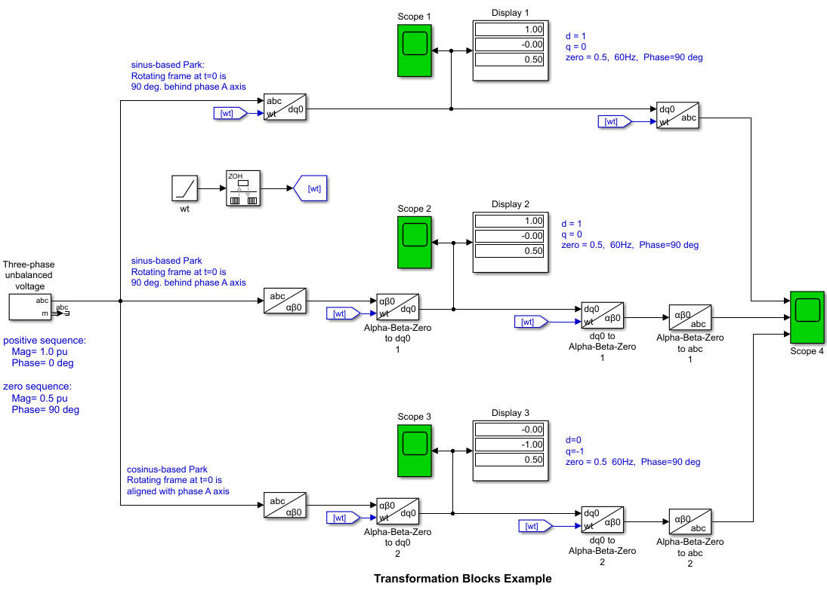

Fig.11.1: Block diagram of three-phase (abc) to two-phase (αβ0) transformation

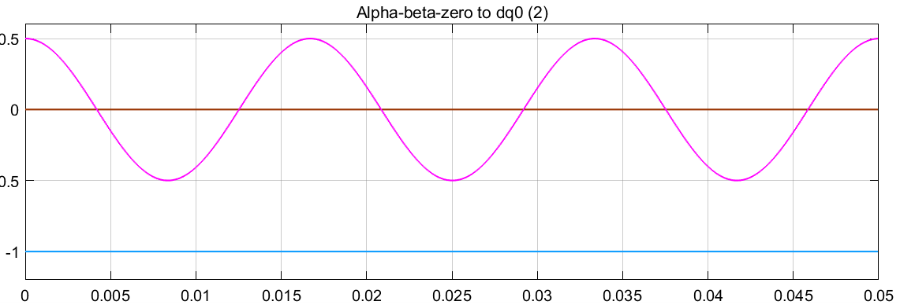

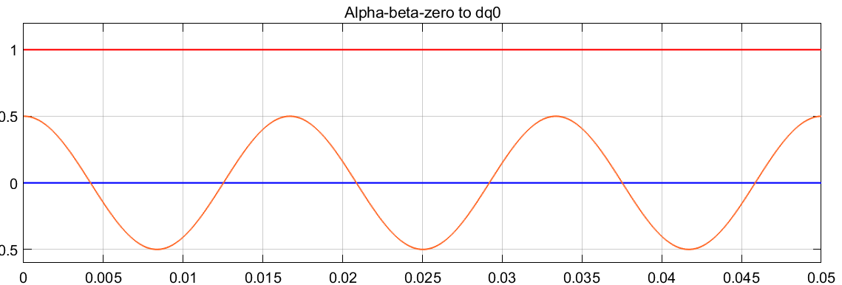

Fig.11.2: Waveform of alpha-beta-zero to dq0

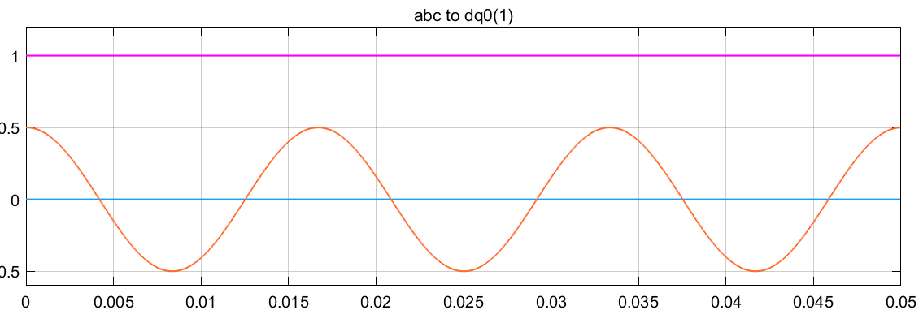

Fig.11.3: Waveform of abc to dq0

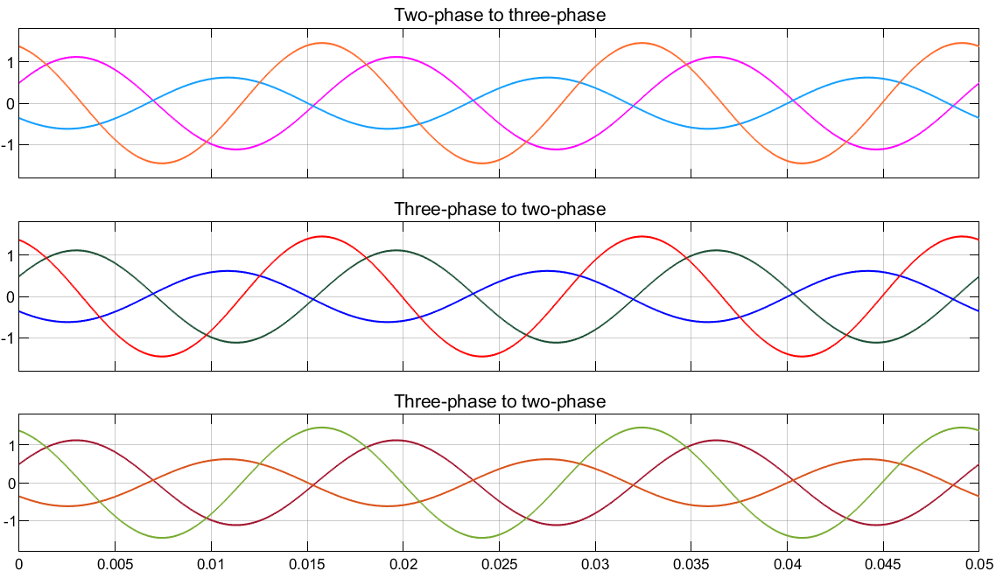

Fig.11.4: Output waveform of three-phase to two-phase transformation and vice versa

* 1. **Discussion & Conclusion**

This experiment thoroughly investigated to analyze on three-phase (abc) to two-phase (αβ0) transformation system. Here, we used to analyze though Clark transformation procedure to determine theoretical result and compare with the simulated output. This ensured if the experiment carried was accurate or close enough. Thus, desired output was observed and the simulation was a success.